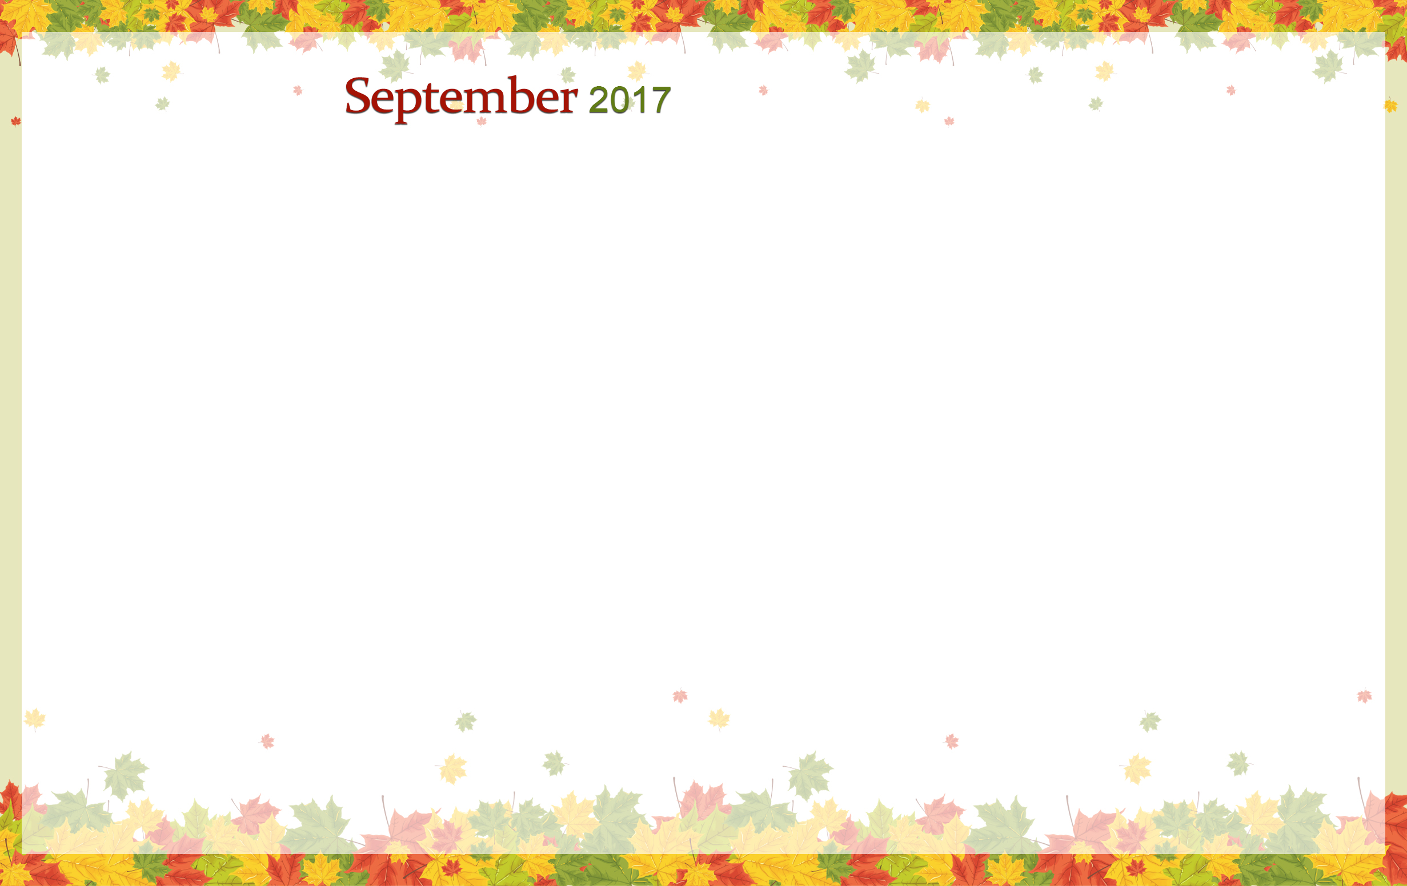
Sunday | Monday | Tuesday | Wednesday | Thursday | Friday | Saturday
 |  |  |  |  | 1 | 2
3 | 4  Labor Day | 5 | 6 | 7 | 8 | 9
10  Grandparents Day | 11 | 12 | 13 | 14 | 15 | 16
17 | 18 | 19 | 20 | 21  Rosh Hashanah | 22  Autumn Begins | 23
24 | 25 | 26 | 27 | 28 | 29 | 30  Yom Kippur

Life Enrichment Calendar  Amber-Coral-Emerald |  |  |  |  | 9:30 Daily Chronicle  9:45 Manicures  10:30 Movement & Meditation (EC)  2:00 Kindness Rocks  3:00 Rest & Restoration  5:45 Creative Coloring | 9:30 Daily Chronicle  10:00 Balloon Toss (IC)  10:30 1:1 Visits  10:45 Refreshments  2:00 Courtyard Visits  6:30 Saturday Night Movie
9:30 Daily Chronicle  10:00 Sunday Mass on TV (KCC)  11:00 Reminisce  1:10 Brewers vs. Nationals  2:00 Courtyard Visits  3:30 Rest & Restoration | 9:30 Daily Chronicle  10:00 Bible Study (SV)  10:30 Exercise (IC)  2:00 Movie Matinee (IC)  3:30 Rest & Restoration | 9:00 Daily Chronicle  9:30 Manicures  10:30 Exercise (IC)  2:00 Lyrics & Laughter (EC)  3:00 Rest & Restoration | 9:30 Daily Chronicle  10:30 Exercise (IC)  2:00 Bean Bag Toss (EC)  3:00 Rosary (CC)  5:45 Creative Coloring w/ Staff | 9:30 Daily Chronicle  10:30 Exercise (IC)  2:00 BINGO! (EC)  3:00 Worship Service (KCC)  5:45 Working Hands Club | 9:30 Daily Chronicle  9:45 Manicures  10:30 Movement & Meditation (EC)  2:00 “Guess That Scent”  3:00 Rest & Restoration  5:45 Creative Coloring | 9:30 Daily Chronicle  10:00 Balloon Toss (IC)  10:30 1:1 Visits  10:45 Refreshments  2:00 Courtyard Visits  6:30 Saturday Night Movie
9:30 Daily Chronicle  10:00 Sunday Mass on TV (KCC)  11:00 Reminisce  2:00 Courtyard Visits  3:25 Seahawks at Packers  3:30 Rest & Restoration | 9:30 Daily Chronicle  10:00 Bible Study (SV)  10:30 Exercise (IC)  2:00 Cooking Club: “Cream Cheese Chocolate Chip Bars”  3:00 Movement & Meditation (EC)  3:30 Rest & Restoration | 9:00 Daily Chronicle  9:30 Manicures  10:30 Exercise (IC)  2:00 Lyrics & Laughter (EC)  3:00 Rest & Restoration | 9:30 Daily Chronicle  10:30 Exercise (IC)  2:00 Spiritual Hour w/ Joelin (EC)  3:00 Rest & Restoration  5:45 Creative Coloring w/ Staff | 9:30 Daily Chronicle  10:30 Exercise w/ Candice (EC)  11:00 Piano Music w/ Christy (EC)  2:00 BINGO! (EC)  3:00 Worship Service (KCC)  5:45 Working Hands Club | 9:30 Daily Chronicle  9:45 Manicures  10:30 Exercise (IC)  2:00 Happy Hour  3:00 Rest & Restoration  5:45 Creative Coloring | 9:30 Daily Chronicle  10:00 Balloon Toss (IC)  10:30 1:1 Visits  10:45 Refreshments  2:00 Courtyard Visits  6:30 Saturday Night Movie
9:30 Daily Chronicle  10:00 Sunday Mass on TV (KCC)  11:00 Reminisce  12:10 Brewers @ Marlins  2:00 Courtyard Visits  3:30 Rest & Restoration | 9:30 Daily Chronicle  10:00 Bible Study (SV)  10:30 Exercise (IC)  2:00 Creative Art Club: “Make a Wish…”  3:00 Movement & Meditation (EC)  3:30 Rest & Restoration | 9:00 Daily Chronicle  9:30 Manicures  10:30 Exercise (IC)  2:00 Lyrics & Laughter (EC)  3:00 Rest & Restoration  3:00 Topaz Kennel Pet Visits | 9:30 Daily Chronicle  10:30 Exercise (IC)  1:30 Shake Loose a Memory w/ Orientation Group  3:00 Rosary (CC)  5:45 Creative Coloring w/ Staff | 9:30 Daily Chronicle  10:30 Exercise w/ Candice (EC)  11:00 Piano Music w/ Christy (EC)  2:00 BINGO! (EC)  3:00 Rest & Restoration  5:45 Working Hands Club | 9:30 Daily Chronicle  9:45 Manicures  10:30 Movement & Meditation (EC)  2:00 Ice Cream Cone Social  3:00 Rest & Restoration  5:45 Creative Coloring  Happy Birthday, Rosemarie! | 9:30 Daily Chronicle  10:00 Balloon Toss (IC)  10:30 1:1 Visits  10:45 Refreshments  2:00 Courtyard Visits  6:30 Saturday Night Movie
9:30 Daily Chronicle  10:00 Sunday Mass on TV (KCC)  11:00 Reminisce  1:10 Brewers @ Cubs  2:00 Courtyard Visits  3:30 Rest & Restoration | 9:30 Daily Chronicle  10:00 Bible Study (SV)  10:30 Music w/ Jeanette (EC)  2:00 Cooking Club: Apple Cinnamon Crepes Live  3:00 Movement & Meditation (EC)  3:30 Rest & Restoration | 9:00 Daily Chronicle  9:30 Manicures  10:30 Exercise (IC)  2:00 Lyrics & Laughter (EC)  3:00 Rest & Restoration | 9:30 Daily Chronicle  10:30 Exercise (IC)  2:00 TimeSlips™ (EC)  3:00 Rest & Restoration  5:45 Creative Coloring w/ Staff | 9:30 Daily Chronicle  10:30 Exercise (IC)  11:00 Piano Music w/ Christy (EC)  2:00 BINGO! (EC)  3:00 Worship Service (KCC)  5:45 Working Hands Club | 9:30 Daily Chronicle  9:45 Manicures  10:30 Movement & Meditation (EC)  2:00 Let’s Celebrate: “Gene Autry”  3:00 Rest & Restoration  5:45 Creative Coloring | 9:30 Daily Chronicle  10:00 Balloon Toss (IC)  10:30 1:1 Visits  10:45 Refreshments  2:00 Courtyard Visits  6:30 Saturday Night Movie
CC-Coral Court, AC-Amber Court, EC-Emerald Court, SV-Sapphire Villa, KCC-Keller Community Center, ADR-Alex Dining Room, IC-Individual Court *Schedule Subject To Change Without Notice*

