**VALLEY VNA SENIOR CARE**

**1535 Lyon Drive, Neenah**

2nd Wednesday of every month

9 am – 12 pm

2nd Thursday of every month

9 am-12 pm

3rd Thursday of every Month

1 p – 4 p

4th Monday of every month

1 pm – 4 pm

4th Tuesday of every month

9 am – 12 pm

1 pm – 4 pm

**MENASHA SENIOR CTR**

**116 Main St, Menasha**

1st Monday of every month

1 pm – 3:40 pm

4th Thursday of every month

1 pm – 3:40 pm

**GREENVILLE YMCA**

**W6931 School Rd, Greenville**

3rd Wednesday of every month 11 am – 2 pm

**NEW LONDON SENIOR CTR**

**600 W. Washington Street**

**New London**

**\*\*Call for an appointment\*\***

**920-538-2974**

2**nd** Friday of every month

9 am – 12 pm

4**th** Friday of every month

10 am – 4 pm

**AMERICAN LEGION**

**536 W. Main St**, **Winneconne**

4th Thursday every other month

9 am – 1 pm

**PINEWOOD APARTMENTS**

**125 Pinewood St, Hortonville**

**3rd** Tuesday every other month

1 pm – 4 pm

**OMRO COMMUNITY CT**

**130 W. Larabee St, Omro**

**3rd** Thursday of every month

9 am – 12 pm

**ST. JAMES UNITED**

**METHODIST CHURCH**

**100 W. Capital – Appleton**

1st Thursday of every month

9:30 am – 12:30 pm

**Oshkosh YMCA (Downtown)**

**324 Washington Ave, Oshkosh**

1st Thursday of every month

1 pm – 3 pm

**OSHKOSH SENIOR CENTER**

**200 N. Campbell Rd, Oshkosh**

*For Appointments Call*

920-232-5310

Multiple clinics held weekly

*We believe everyone deserves quality care while they age with joy, dignity and grace. For more than 100 years, Valley VNA has been a nonprofit trusted community resource.*

*We are dedicated as a continuum of care provider with In-Home Care, keeping you safe and independent in your home. Independent senior apartments, assisted living and memory care.*

*****We are a Diamond Accredited organization with Wisconsin Assisted Living Association providing quality care for those in our care.*



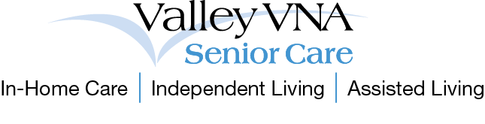Each clinic is 20 minutes in length and includes a foot soak, nail trimming filing, callus reduction, education/referral and foot massage with lotion.

Please bring a hand towel to your scheduled appointment.

**Please call for appointments:**

**920-727-5555 - Fox Cities**

**920-426-1931 - Oshkosh**

**920-538-2974 - New London**

**Valley VNA Senior Care**

**1535 Lyon Drive, Neenah**

**920-727-5555**

**866-930-8862-Toll Free**

**www.valleyvna.org**



**FOOT CARE**

**CLINICS**

2019

Schedule

**Put your best foot forward!**

